Strategic Management Project: Coca-Cola Company
Student’s Name
Institutional Affiliation

Table of Contents
Executive Overview 3
Strategic Management Project: Coca-Cola Company 4
Introduction of the Company 4
Coca-Cola and its Products. 4
Coca-Cola History. 4
Mission and Vision. 5
External Assessment of Coca-Cola Company 6
EFE analysis of Coca-Cola Company. 6
Competitive Profile Matrix (CPM) Analysis of Coca-Cola Company. 8
Internal Assessment of Coca-Cola Company 9
Internal Factor Evaluation (IFE) of Coca-Cola Company. 9
Coca-Cola Financial Ratio Analysis for The Year 2016 And 2015 12
Key Conclusions and Strategic Implications. 13
Analysis of Internal Capabilities and Implications on Strategic Decisions. 13
Current Strategy 13
Recommended Strategy Changes 15
SWOT Analysis of Coca-Cola Company 16
BCG Analysis of Coca-Cola Company 19
SPACE Analysis of Coca-Cola 21
Product- Positioning Map 23
Strategies and Objectives for most Favorable Market Position 25
Selected Strategy: Product Portfolio Diversification. 26
Implementation and Assessment Plan 27
Financial Projection 29
Coca-Cola 3-Year Financial Projection. 30
References 31

Executive Overview
Coca-Cola company is an American based multinational organization with its headquarters in Atlanta. The latter is incorporated in Delaware as a beverage corporation that manufactures, retails and markets beverages with no alcohol content and syrups. The main events in the history of Coca-Cola that have facilitated its current success are based on acquisitions. Coca-Cola acknowledges the dynamism of the business world and believes that for the organization to continue thriving they it must be future-oriented. EFE analysis of Coca-Cola indicates that the organization has opportunities to thrive on its extended reach and creation of a culture that is based on the acquisition. Some of the threats that the organization faces include the scarcity of raw materials and the changing consumer needs. The Competitive Profile Matrix analyzes the organization based on critical success factors like brand loyalty, global expansion and the size of the organization. The IFE analysis of the organization indicates that some of Coca-Cola’s strengths include high brand equity and favorable economies of scale. Among the weaknesses thereof is negative publicity and poor management of water. The financial ratio analysis indicates that Coca-Cola has maintained high levels of success over the years because of proper management of its strengths and weaknesses as well as of its opportunities and threats.
The organization have managed to become one of the brands that are most recognized around the world, a factor that may be attributed to the establishment and implementation well laid out strategies. Considering the changing market conditions, it may be necessary for Coca-Cola to consider altering the approach it takes towards the same. The SWOT analysis of the organization gives a detailed description of the organization’s strengths and weaknesses while the BCG matrix clearly defines the value of different organizational products to Coca-Cola. The SPACE matrix provides a detailed description of Coca-Cola’s financial position as regards competitive advantage, industrial and environmental stability as well as financial strength.
The product position map indicates Coca-Cola is a market leader that faces stiff competition from Pepsi. The recommendations made concerning alternative strategies that the organization can use to maintain a favorable market position include the introduction of healthier drinks, better resource management, changes in the supply chain, increasing popularity of less popular brands, establishing the organization as a beverage rather than a soft drink company and product diversification. The most suitable strategy discussed is product portfolio diversification which if implemented is expected to allow the organization to maintain its position in the market and allow it to grow, as depicted in the financial projections.

Strategic Management Project: Coca-Cola Company

Introduction of the Company

Coca-Cola and its Products.
Coca-Cola company is an American based multinational organization with its headquarters in Atlanta. The latter is incorporated in Delaware as a beverage corporation that manufactures, retails and markets beverages with no alcohol content and syrups. The organization is known to produce the signature drink, Coca-Cola, invented by John Pemberton in 1886 in Georgia. Asa Candler bought the Coca-Cola formula in 1892 and incorporated the organization which has operated as a distribution business operating in all countries all over the world (Armus, 2005). The Coca-Cola company currently headed by Muhtar Kent as chairperson and James Quincey as president and CEO regards itself as so much more than a Coca-Cola producer considering that they offer other products including organic tea and coconut water (Company et al., 2017).
Among the assets that Coca-Cola possess are non-food products including Columbia pictures and World of Coca-Cola. Columbia Pictures was a film company that Coca-Cola bought in 1981 which was sold to Sony in 1987. On the other hand, World of Coca-Cola is a themed tourist attraction located in Atlanta that facilitates the staging of an exhibition on a multistoried structure. The experience is also characterized by sampling of different flavors as well as a feature of museum history (McLellan, 2006). Tab is another brand associated with Coca-Cola which was the organization’s first attempt at introducing a diet drink. However, its sales dropped drastically with the introduction of Diet Coke (Coffey, 2008). Other soft drinks that Coca-Cola produces include Fanta, Sprite, and 7Up. Due to the changing consumer preferences and the demand for healthy drinks, Coca-Cola introduced Minute Maid, Nestea, and Fruitopia among others.
Coca-Cola was recognized as a global brand in 2010 and crowned the best soft drink company in many countries except for the Middle East. Regardless, in the latterly named region Coca-Cola holds a 25% market share with the biggest shareholder being Pepsi with 75% market share. However, in 2003 the market share growth of Coca-Cola increased by double digits meaning that in the future if the growth rate holds Coca-Cola may acquire a larger market share in the Middle East. In Scotland, a locally produced soft drink, Irn-Bru, was initially more popular than Coca-Cola brands but has currently been phased out by Coca-Cola and Diet Coke (Pike, 2009).

Coca-Cola History.
The main events in the history of Coca-Cola that have facilitated its current success are based on acquisitions. In 1960 Coca-Cola made its first acquisition of Minute Maid followed by Thums Up in 1993 plus Barg’s in 1995. The trend continued with the acquisition Odwalla branded smoothies, juices, and bars in 2001 followed by that of Fuze Beverage for $250 million. Later, in 2009, Coca-Cola tried to acquire the Chinese Huiyuan Juice Group but failed because the amount they were offering was rejected. Among other investments that Coca-Cola has made with that regard include the purchase of Columbia pictures at $692 million and selling it to Sony after 7 years $3billion. As of 2013, Coca-Cola finished purchasing ZICO, a company that produces coconut water, further diversifying the Coca-Cola products. The same applied to the purchase of Honest Tea Company in 2011. Furthermore, as of 2015, Coca-Cola became a minimum stakeholder of Suja Life LLC known for the manufacture of cold-pressed juice (Esterl, 2016).
Since the establishment of the organization in 1886, Coca-Cola has continued to offer its consumers a taste that is both unique and refreshing leading it to become the biggest beverage company in the world. To reach its customers around the globe, the organization has been relying on, and still relies, on a network of associates who facilitate the same leading to the success of Coca-Cola. The organization is also keen to note the changes in consumer preferences, a factor that led to the diversification of the products offered to consumers including those with reduced sugar levels and higher nutritional value. Coca-Cola has also managed to remain in business over the years because of the strategic creation and maintenance of an associated network, partnerships and lasting value based shareholder, customer and community relationships (Company et al., 2017).
Dating back to as far as 1938, the leadership at Coca-Cola has emphasized on matters concerning the health and well-being of its consumers, highlighting the necessity of proper nutrition as well as exercise to achieve the same. Similarly, in the latterly expressed year, Coca-Cola introduced a game, “Steps to Health” to Canadian consumers that focused on the importance of regular exercise and a balanced diet. Considering that Coca-Cola Company has a wide reach based on the uniqueness of the brand the organization has used the latter throughout the period of its existence to distribute both products and resources that facilitate the establishment of healthier and happier communities. Moreover, in 1960, the organization launched an “Eat Right, Be on the Ball and Have Fun” campaign through booklet distribution to educate teens on the means of building strong bodied through proper nutrition with information to guide their caregivers on the basics of good nutrition (Company et al., 2017).
On matters concerning competition, Coca-Cola company has managed to stay ahead of its competitors over the years because of the exclusive partnerships that it has managed to establish with vendors including restaurants and cinemas, who tend to offer Coca-Cola drinks over Pepsi. Additionally, when sponsoring sports events Coca-Cola company eliminates competition by acquiring sole rights to sell while exploiting opportunities to sell to VIPs and other important clients, strategies that define the organization’s direct marketing approach. The biggest competitor of Coca-Cola company is Pepsi, which was involved in the ‘Cola Wars’ where blindfolded consumers seemed to love the taste of Pepsi products compared to those of the new Coca-Cola ones. The latter caused a drastic decrease in sales for Coca-Cola while increasing those of Pepsi at the same rate. Coca-Cola beat the competition by recalling the new drinks and reintroducing the old formula to the market as Coca-Cola Classic (McKelvey, 2006).

Mission and Vision.
Coca-Cola acknowledges the dynamism of the business world and believes that for the organization to continue thriving they it must be future-oriented. Therefore, the organization prides itself on understanding the forces as well as trends that are likely to affect the future of the business facilitating the creation of strategic approaches to business. The organization mission is divided into three parts. The first part of the same indicates that Coca-Cola Company aims at being a world-class refreshment that satisfies the bodily, mental and spiritual needs of its consumers. Similarly, Coca-Cola company is looking to inspire moments that are filled with happiness and optimism through their brands and actions thereof. Finally, Coca-Cola is looking to make a difference and add value to the lives of the consumers and all those affected by the brand. Evidently, Coca-Cola’s mission is to ensure that their brand becomes more than a refreshment such that people can identify with the same on different levels including of the mind, spirit, and body. Coca-Cola aims at creating happiness through value creation thus facilitating achievement of its objective to make a difference (Company et al., 2017).
According to Coca-Cola Company, the organization has developed objectives that they seek to achieve with the help of their bottlers to enhance the achievement of their mission. The company looks to inspire the people within it and encourages mutual inspiration through the provision of great working conditions. Clearly, Coca-Cola acknowledges the role that teamwork plays in organizational success and as such seeks to enhance the same. Also, the organization offers a drink portfolio that looks to satisfy the predicted needs and desires of people around the world. Consumers are king of business thus satisfying their needs is a primary concern for Coca-Cola. The organization further affirms the need for teamwork by creating a network of partners that also stresses the necessity of mutually expressed loyalty. Also, Coca-Cola plays a vital role enhancing the sustainability of the planet as a responsible global citizen that is looking to make a difference. Finally, the organization looks to maximize returns, in the long run, to benefit its shareholders while maintaining focus on its overall responsibilities (Company et al., 2017).

External Assessment of Coca-Cola Company
An organization’s success is affected by both internal and external factors. External factors account for the determinants outside the organization that are likely to affect its success and productivity but cannot be controlled by the same. Thus, to guarantee the success of a business it must evaluate the external factors thereof and strategize on the best way maximally exploit the same. Some of the external factors to an organization include the consumer base, the changing trends, the law, infrastructure, the weather as well as the financial and economic conditions of the state within which it exists (Dhalla, 2007).

EFE analysis of Coca-Cola Company.
The EFE matrix is used to summarize the threats and opportunities that an organization faces in its external environment based on at least any five major external factors, named above. Some of the opportunities that present themselves to Coca-Cola company are based on the diversification of its product portfolio which has seen the organization penetrate in promising upcoming beverage markets and increase its customer base. Also, Coca-Cola has extended reach through introducing new products that better suit the changing consumer needs may aid in maintaining its consumer base and also attract new consumers. Developing nations have offered Coca-Cola a new consumption base in which case their inhabitants are heavy consumers of Coca-Cola products regardless of whether they are healthy or not. Exploitation of the latterly expressed market by the organization may lead to increase in the profits made considering that intake of their drinks doubles during the hotter seasons in the latterly named companies. Coca-Cola has established a well-structured supply chain management system that ensures that the business keeps thriving regardless of the changes in transportation and distribution costs. However, the organization should ensure that relevant adjustments are made on the same regularly. Similarly, the organization should focus on marking the products that have not been fully accepted in the market to attract new customers and increase their market base (Ayub et al., 2013).
Coca-Cola has a brand name that has a good reputation and as such, exploitation of the same is likely to create opportunities for exploiting new market niches and increasing the organization’s profit levels. The introduction of bottled water to its product portfolio has opened up new markets for Coca-Cola that can be further exploited considering that the consumption rates for the same are increasing. Considering that Coca-Cola is a successful company that has existed for a long time, it has acquired the means to acquire other companies that produce different products from its own, offering the organization an opportunity to explore and harness new markets (Zishan, 2017).
On the downside, the threats that Coca-Cola faces are based on the consumer preference changes whereby consumers are looking to purchase drinks that are healthier with an added nutritional value. The amount of sugar that is used in manufacturing Coca-Cola products eliminates them from such a list. Also, indirect competition from organizations like Starbucks is a threat to Coca-Cola because of the availability of alternatives and varieties that consumers can choose from to that effect. The latter is likely to cause a loss in market share for Coca-Cola. Water is one of the raw materials that Coca-Cola uses in the manufacture of its products and the scarcity of the same possess a threat to the production of Coca-Cola products. In another instance, in Venezuela, due to a reduction in sugar supply, the manufacture of Coca-Cola products had to be reduced. Some of the ingredients that are used to manufacture Coca-Cola products have been proven to have negative medical effects on consumers, like properties of the coca plant and cola nuts, a factor that has led to reduced intake of the same as consumers’ preferences change to healthier drinks (Pendergrast, 2013). Also, Pepsi offers the greatest competition to Coca-Cola, thus is the biggest threat to the organization. The legal necessity to disclose negative product effects possess a threat to Coca-Cola whose certain carbonated products have adverse medical effects on the consumers. Moreover, Coca-Cola over-relies on bottling companies to which it sells its concentrates and syrup for profits, with over 80% of Coca-Cola products being distributed bottling companies (Zishan, 2017).

EFE Matrix
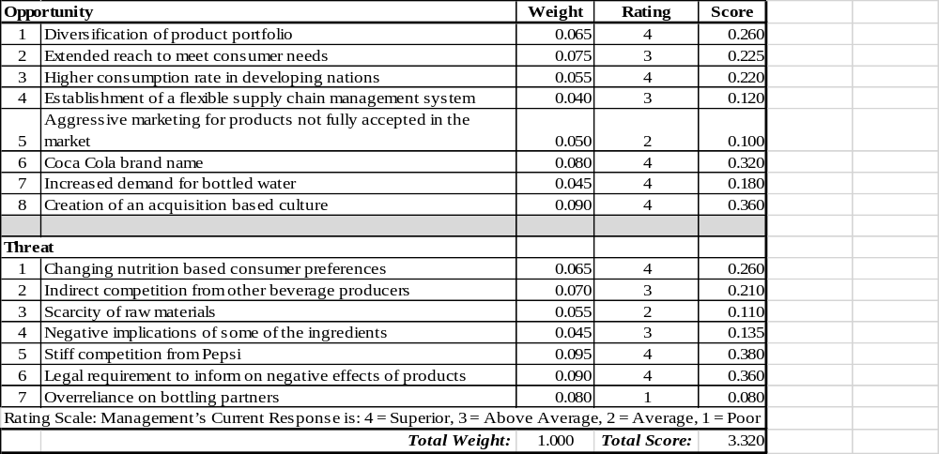

Competitive Profile Matrix (CPM) Analysis of Coca-Cola Company.
The CPM matrix facilitates the comparison of an organization with its direct competitors based on the critical success factors in the industry that they belong to. The latter is centered on the determination of the strengths and weaknesses of organizations compared to their competitors and helps determine whether a company is successful or not when compared to those that it competes with (Sohel et al., 2014). Coca-Cola company belongs to the beverage industry with its main competitors being Pepsi and Cadbury Schweppes. Coca-Cola holds the largest market share, that is, 43%, Pepsi holds 31% while Cadbury Schweppes holds 18%. Other players in the industry hold the remaining 8% (Fosfuri & Giarratana, 2009).
The critical success factors in the latterly named industry include the size of the organization. The latter is important as it allows the determination of whether a given organization can manage to negotiate to be the sole supplier during a specific period. Next is brand loyalty in which case consumers of carbonated drinks prefer to consume a single brand in which case to maintain loyalty, factors like brand image are necessary to consider. Product price is another important factor since consumers whose decisions are not based on brand loyalty will be based on price. Thus, beverage companies must offer their products at pocket-friendly competitive rates. Also, global expansion is important to consider since the American market is saturated in the beverage industry. To maintain their success, beverage companies must explore new markets in other parts of the world (Bethuy et al., 2007).
In a dynamic business world like the one that currently exists, product innovation is necessary to maintain the success of brands which must constantly adapt to the changing consumer needs. Moreover, consumption of soft drinks must pose the least negative health effects on consumers who are likely to stop consumption if they realize that the drinks have negative impacts on their health. Thus, beverage companies must ensure that the ingredients used to create the final product are safe for consumption. To attract and maintain consumers, soft drink producers must come up with entertaining and informative advertisements that create awareness about their brand. A good marketing strategy based on the brand advertisement is key to the success and productivity of a given brand. The kind of customer service that a brand offers has a direct effect on retention of their consumers thus is an important factor regarding organizational success. Additionally, the financial position of an organization determines its capability to handle business-related practices including its distribution network and Corporate Social Responsibilities. A better financial position means that the latter will be well handled facilitating maximization of resources and assuring higher profit margins (Bethuy et al., 2007).

CPM Analysis
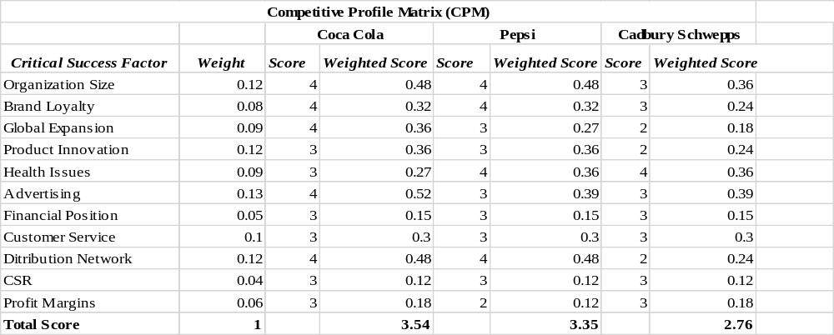

Internal Assessment of Coca-Cola Company
As indicated above, organizational success is dependent on both its internal and external factors. Internal factors that affect businesses are the determinants of a given organization that affect the approach taken by the business as well as its operational success. One of the most critical internal factors that affect a business is the leadership style that is employed as well as the management system both of which determine organizational culture. Similarly, communication is a key internal factor that affects the way the business is run as well as the employee relations within the same. The communication channels in an organization are affected by both the management and leadership systems in place thus the success of the latter is key to the success of the established communication systems. Also, critical to internal organizational success is the level of employee motivation in which case high levels of the same are likely to assure organizational success (Fosfuri et al., 2009).

Internal Factor Evaluation (IFE) of Coca-Cola Company.
The IFE matrix is a strategic assessment tool that is used to evaluate organizations based on their internal strengths and weaknesses. The matrix allows the evaluation of the relationship between the strengths and weaknesses of the organization in question, providing an insight of strategic measures that should be taken to ensure its success in the future ( David, 2011).
One of the strengths of Coca-Cola company lies in its increased success in creating brand awareness. Coca-Cola brand is known across the globe with its logo and brand colors being unmistakably popular among people from different regions of the globe. The latter is key to the maintenance of organizational success through maintenance and expansion of market share. Similarly, Coca-Cola has a large distribution network that allows it to distribute about 500 different product variants to 200 nations across the globe, a factor that assures large profit margins for the organization. Also, Coca-Cola registered a massive increase in revenue in three main areas including Latin America, South and East Asia, the Pacific Rim and in bottling investments. Increased revenue means increased profits which account for organizational success and its chances for survival in the future (Zishan, 2017).
In 2011, Coca-Cola was named the brand with the highest brand equity as well as unique identity a factor that makes it clearly distinguishable from its competitors. The latter is key to ensuring that the latter maintains its consumer base and also attracts new consumers to enlarge the same. Also, Coca-Cola has been named as one of the most valuable organizations around the world with its current value being approximately 79.2 billion dollars. Moreover, Coca-Cola is recorded to be the soft drink producer with the largest market share accounting for about 43% of the same. The organization has also implemented futuristic and wholesome marketing strategies that target people across all ages giving it a competitive advantage over the rest of the producers in the beverage industry. Furthermore, Coca-Cola continues to maintain high levels of customer loyalty based on the excellence of the quality of its products. The latter means that the organization can maintain its market share, further assuring its future success. Coca-Cola’s economies of scale allow the organization to share the fixed costs of production over about 500 different products allowing the company to offer its products to consumers at pocket-friendly rates. The size of Coca-Cola company allows the same to be capable of demanding lower prices from suppliers, underpricing certain products to increase their competitive advantage as well as acquisition smaller brands to diversify product portfolio and curb competition (Baah & Bohaker, 2015).
Among the weaknesses that Coca-Cola company has to deal with is competition from strong market players like Pepsi. With such soft drink producers competing for market share, it means that there is a smaller consumer base that Coca-Cola reaches because other consumers may prefer products from the competing brands. Another issue affecting Coca-Cola is currency fluctuation among different countries that it supplies its products to. If the currencies in the said companies are not strong, the latter translates into decreased revenue for Coca-Cola. Also, considering that water is one of the main ingredients used to make Coca-Cola products management of the same must be prioritized. Water scarcity has led to increased costs of acquisition which have lowered Coca-Cola profit margins. Consumer tastes are moving towards the consumption of healthier products meaning that the revenue that Coca-Cola Company acquires from consumption of carbonated drinks is likely to reduce. Coca-Cola has also been faced with lawsuits based on the violation of human rights or unethical practices, factors that have tainted the brand name and if not well handled are likely to affect the brand image and consequently brand loyalty.

IFE Matrix
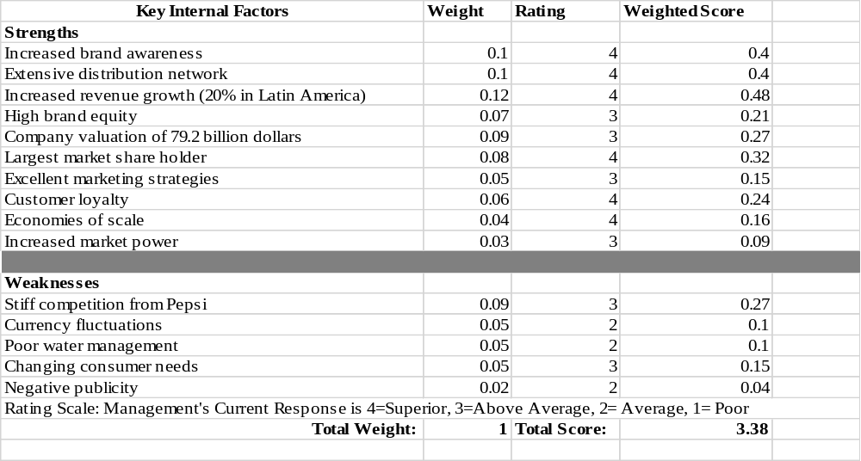

Coca-Cola Financial Ratio Analysis for The Year 2016 And 2015
 | FORMULA | 2016 (Millions) | 2015 (Millions)
LIQUIDITY
- Current Ratio | Current Assets/Current Liabilities | $34010/26532  =1.28 | $33395/26929  =1.24
- Quick Ratio | (Current Assets-inventory- prepaid expenses)/ Current Liabilities | ($34010-2675-2481)/26532  =1.09 | ($33395-2902-2752)/26929  =1.03
PROFITABILITY
- Operating margin | Operating Income/ Net Sales | $8626/41863  =20.61% | $8728/44294  =19.70%
- Net profit margin | Net Income / Net Sales | $6527/41863  =15.59% | $7351/44294  =16.60%
- Return on total assets | Net Income/ Average Total Assets | $6527/  ((87270+89996)/2)  =7.36% | $7351/  ((89996+92023)/2)  =8.08%
- Basic Earning Power | EBIT/ Total Assets | 1.51 | 1.69
- Return on Common Equity | Net Income/ Total Shareholder’s Equity | $6527/$23220  =28.11% | $7351/25764  =28.53%
ASSET MANAGEMENT RATIOS
- Inventory turnover ratio | Cost of Goods Sold/ Average Inventory | $16465/  ((2675+2902)/2)  =5.90 times | $17482/ ((2902+3100)/2)  =5.83 times
- Days Sales Outstanding | (Accounts Receivable/Net Credit sales)365 | ($3856/41863)365  =34 days | ($3941/44294)365  =32 days
- Total asset turnover ratio | Net Sales/ Average total assets | $41863/  ((87270+89996)/2)  =0.47 times | $44284/ ((89996+92023)/2)  =0.49 times
DEBT MANAGEMENT RATIOS
- Total debt to Total assets | Total Liabilities/Total Assets | $64050/87270  =0.73 | $64232/89996  =0.71
- Times Interest Earned Ratio | EBIT/ Interest Expense | $8626/733  =11.77 times | $8728/856  =10.20 times

Key Conclusions and Strategic Implications.

As per the liquidity ratios, the liquidity position has improved slightly from the year 2015 to the year 2016. The quick ratio is more than 1.0 meaning that Coca-Cola can meet its short-term obligations effectively. Moving forward, the company should ensure that there more effort is put to maintain or even the liquidity position through proper management of the inflow and outflow of cash.
The profitability ratios all show a decline in profitability in the year 2016 as compared to the year 2015. Some strategies to boost profitability in the coming year may include boosting sales or minimizing the cost of production and other operating expenses. The decline in profitability can be quite discouraging to potential investors and therefore this should be addressed immediately.
The inventory turnover ratio has increased slightly from 5.83 times in 2015 to 5.90 times in 2016. This suggests improvement in inventory management in terms of ensuring that it is converted to sales. However, strategies should be implemented to improve this ratio further and have more inventory converted into sales. Days Sales Outstanding have increased from 32 days in 2015 to 34 days in 2016. This means that the management is not managing accounts receivable effectively. Debtors should be encouraged to settle their outstanding amounts through strategies such as period discounts. There is a decline in the total asset turnover ratio meaning that Coca-Cola should also implement strategies to manage assets better for increased sales and profitability.
Finally, Coca-Cola has improved on debt management as seen with the increasing total debt to total assets ratio and the time's interest earned ratio. More strategies should be implemented to ensure that the liabilities are settled on a time and there is less funding from debt sources.

Analysis of Internal Capabilities and Implications on Strategic Decisions.
From the analysis above, it is evident that Coca-Cola has maintained high levels of success over the years because of proper management of its strengths and weaknesses as well as those of its opportunities and threats. Regardless, moving forward, Coca-Cola should seek to reduce the threats that it faces in the industry by relatively turning them into opportunities. Similarly, the management of the organization should work towards eliminating the weaknesses that the organization exhibits to further increase their chances of success. On the other hand, the exploitation of both the strengths and opportunities available to the organization should be maintained to guarantee its success in the future.

Current Strategy
Coca-Cola has managed to become one of the brands that is most recognized around the world, a factor that may be attributed to the establishment and implementation well laid out strategies. Initially, the founders of the company began their business based on a well-researched market formula. Pemberton sent samples of the formula that he intended to use to create early versions of soda to the lab for assessment and on receiving feedback he refined his formulas and created unique flavors that would satisfy the tastes of customers. Furthermore, the first recipe that was used to make Coca-Cola drinks remains a well-guarded organizational secret that has been rumored to be locked in a vault in Atlanta. Regardless of the minor changes that have been made to the original recipe of Coca-Cola, including the removal of cocaine from the ingredients used to make the drink, the recipe of the same has been constant allowing the organization to save time that would have been spent on creating new tastes that would suit regional markets in different parts of the world (Butler & Tischler, 2015).
Additionally, the font that was used to create the Coca-Cola logo in 1923 has remained the same considering that the selection process ensured that it was standardized thus giving it a timeless aspect. The latter equally saves the time and resources that the company would use to keep changing the same to fit market trends. Also, the packaging of Coca-Cola drinks was made unique with the aim of giving the organizational products a look that indicated it was a premium drink that would not be compared with others in the market. Retailers of Coca-Cola products were also tasked with guaranteeing that product quality was maintained by ensuring that they never serve the drink when its temperature is above 40 degrees. Similarly, the organization managed to maintain the price of their drink at a constant for about seventy years thus, they were able to establish consumer loyalty among consumers. The company also adopted a word-of-mouth advertising concept that allowed it to create a voice of its own and it also became the first company to attach its brand name to items that did not have any relations with its products like calendars and clocks. Most importantly Coca-Cola also adopted a franchise model that entailed giving up their bottling rights and is currently working with about 250 bottlers who are independent entities (Butler & Tischler, 2015).
Currently, Coca-Cola is working towards increasing their revenue and growing their profits through segmented growth strategies that vary depending on the type of market that they are operating in. Employee incentives are aligned with the prevailing growth rate and in new markets, the organization looks to increase the volume of their products while maintaining their affordability, a tactic for establishing a firm foundation for success in the future. On the other hand, to succeed in developing markets Coca-Cola tries to maintain a balance between product pricing and the volume that is supplied. In developed markets, the organization diversifies their product and price mix through the introduction of small and premium packages hence facilitating value creation based on the customer tastes. To solidify their success in the market, Coca-Cola has continuously invested in their brand through the implementation of better marketing strategies and the increase of both the quality and the quantity of advertising. Moreover, they have created a beverage portfolio that is extensive including the establishment of partnerships with producers of other products like Monster Beverage and Suja. Recently, in 2015, Coca-Cola launched a global campaign for all its products with a slogan that emphasizes tastes, personal connections, and refreshment, “Taste a Feeling.” The latter seeks to ascertain that regardless of the Coca-Cola product that one chooses to drink, they will always get the satisfaction they need (Schneider, 2016).
The organization is also focused on increasing their efficiency considering they intend to boost their growth momentum, an end they have also tried to reach by enhancing their financial flexibility and implementing better marketing strategies. Hence, Coca-Cola has managed to improve their productivity and efficiency and still reduced the costs thereof. The organizational budget is also assumed to start from zero such that it must be justified instead of being carried over to the next year. They are working to drive productivity and continued savings in the company in the hope that the latter will make the organization stronger and better (Schneider, 2016). Furthermore, the organization is trying to build a brand that is consumer-centered such that it manufactures its products based on what the consumers want rather than what the organization deems fit. The latter has led to the introduction of sugar-free drinks as consumer tastes take a healthier turn. Coca-Cola is looking to put the needs of their consumers first, accounting for their move to abide by the recommendations of health authorities with regard to the ingredients and quantities thereof, used in the production process.
Similarly, technology plays a major part in the success of the organization, especially in the marketing department. Coca-Cola makes investments in millions of dollars in the digital marketing sector and it will continue to increase investments in the same to enhance its success within the industry. The company has managed to exploit technology to build closely knit relationships with their customers through social media and mobile applications to run consumer loyalty programs like’ My Coke Rewards’. The organization’s IT department is also looking to exploit the resources available to it to come up with revolutionary strategies that would boost marketing of their products. Admittedly, the application of IT as a strategic tool has so far proven to be beneficial to the organization thus accounting for the continued exploitation of technology to further increase the organization’s competitive advantage (Levin, 2013).
Coca-Cola has also simplified the company despite the rapid changes that have plagued the beverage industry in recent years. The changing tastes and preferences of consumers of Coca-Cola products coupled with the technological evolutions affecting the production and supply chains have made it necessary for organizations to adapt fast and precisely to maintain their position in the market. To cope with the trends in the industry, Coca-Cola reshaped their business by eliminating functional management and directly linking regional businesses to their headquarters. Similarly, evaluation of their internal processes has allowed them to eliminate the barriers that would hinder organizational effectiveness and responsiveness to prevailing market conditions. To crown it all, they have established means to create a satisfying career environment for their employees to keep them motivated and committed hence reducing turnover rates. Finally, the organization has refocused on their core business model to an extent that they are currently associated with over 500 brands encompassing juices, coffee and sparkling water with about 20 of them generating more than a billion dollars in yearly sales. Also, the organization has managed to effectively lead a sophisticated and independent team of bottlers and still created value for their retailers. Management and acquisition of bottling partners have sort to improve performance and manage both production and distribution (Schneider, 2016).

Recommended Strategy Changes
Obviously, Coca-Cola Company was built mainly based on the high affiliations of consumers to drink their sugary beverages. On realization that such drinks are main contributors to the development of lifestyle diseases like diabetes and obesity, their intake has greatly reduced with consumers preferring healthier choices. Sugary drinks from the company are no longer as highly demanded a factor that has caused the organization to lose revenue with that regard. To keep up with the market trends and remain a world leader, the Coca-Cola name is now associated a wider variety of products including waters, energy drinks, and coffees, all of which the organization introduced to maintain high sales levels regardless of changing consumer tastes. Also, the organization introduced Diet Coke in the hope that they would maintain the popularity of their soda brand but on the realization that the low-calorie drink had artificial sweeteners that are unhealthy, consumers interests in the same reduced. So, considering that the organization has built its name around its soda brand, it is not willing to allow its decline. As the management team looks to make their soda brand as popular as it once was it may be a good time to completely alter the recipe used in its production. Despite the need to maintain the authenticity of the brand, after about more than a century of success while relying on the same soda recipe, the organization should consider introducing a newer version of its sodas based on a newly developed recipe that will adhere to the dietary and health recommendations that are currently proposed health institutions (Solomon, 2009).
Similarly, the organization needs to put more effort in dealing with its main competitor, Pepsi Company. The latterly named organization has put Coca-Cola on its toes for a long time and it is not about to give up on its quest to take over the beverage industry. Thus, Coca-Cola’s strategies against competition should be revised to ensure that the organization offers an equally great competitive force to Pepsi in all sectors of the market that the latter has invested in including the diversification of products into the snack segment (Nair & Selover, 2012). Also, Coca-Cola should increase its focus on offering their consumers healthier product options to appeal to their tastes and maintain their loyalty. This means that the brand should be open to creating and adopting a new healthier drink as the signature brand product to better suit the needs of the consumers in its target market.

SWOT Analysis of Coca-Cola Company
The SWOT analysis is a management technique that is used to determine the strengths, weakness, opportunities, and threats that a given organization faces facilitating strategic planning that will guarantee the organization’s success. When conducting a SWOT analysis, it is important to note that the strengths and weaknesses that are analyzed account for the internal factors affecting the organization whereas the opportunities and threats account for the external factors affecting the same. On the other hand, the weaknesses and threats characterize the negative forces that the organization faces whereas the strengths and opportunities account for the positive forces that are likely to propel an organization to success (Helms & Nixon, 2010).
The strengths that are associated with Coca-Cola company as an organization include its brand equity qualities. In 2011, Coca-Cola was formally acknowledged to be the brand with the highest equity considering its brand uniqueness and extensive presence in regions around the world. The company has also been valued highly and it ranks among the top most valuable organizations around the world. The high valuation encompasses all aspects including the spread of organizational assets around the world, the value of the brand and the increased number of factories encompassing the costs and profits associated with Coca-Cola. It is needless to say that Coca-Cola is one of the few companies that has managed to penetrate different regions of the world and is currently present in about 200 countries. The organization’s global presence has largely contributed to the growth of its brand name that is unmistakable regardless where one goes. Moreover, Coca-Cola has the largest market share in its market niche with its most persistent competitor being Pepsi. The organization has also created and implemented effective marketing strategies that primarily target people of all ages thus, giving it a competitive advantage over Pepsi, whose marketing strategies target youngsters alone. Considering its long-term existence in the industry, Coca-Cola has managed to establish customer loyalty that is based on its consistent production of high quality and satisfying products. Also, the distribution network that has been established to cater to the supply needs of Coca-Cola products is large allowing the organization to command high market presence. Coca-Cola operates based on a unique departmentalization strategy such that the organization itself focuses on marketing, branding and the creation of new products and their bottling is handled by independent bottlers (Berry, 2010).
The main weakness that Coca-Cola has to deal with is the stiff competition from Pepsi. Regardless of Coca-Cola being the obvious market leader, Pepsi is constantly implementing new strategies to garner the position for themselves thus being a constant threat to Coca-Cola. Although Coca-Cola has largely diversified the products that it offers its consumers to include healthier choices like waters and teas, the diversification levels are low since the organization has not moved into the snack market like is the case with its main competitor, Pepsi. The snack market has proven to be an essential revenue generator for Pepsi making Coca-Cola’s lack of entrance in the same niche a waste of an opportunity to generate more revenue. In the current state of the beverage market, consumers are increasingly aware of their health needs. They prefer choices that will allow them to lead healthy lifestyles that are not likely to facilitate the development of lifestyle diseases and conditions like obesity and diabetes. In countries that people would rather consume healthier beverages, the sales of Coca-Cola’s carbonated drinks may drop drastically costing the company the much-needed profits. Similarly, Coca-Cola has been called out for having poor water management strategies to an extent that the organization has been charged with overexploitation of water sources in regions where supply is low. The organization has also been accused of mixing pesticides with water to rid it of contaminants without considering that the pesticides would be harmful to the health of those who consume the ‘purified’ water. Furthermore, Coca-Cola operates in countries where currency value is distinctly different which makes it hard for the organization to track their financial well-being as regards revenue collected, assets and expenses especially when the foreign currencies fluctuate (Bose, 2008).
In a constantly changing business environment, the opportunities available to Coca-Cola are numerous and diverse. First, the organization may choose to diversify their product portfolio to include healthier choices of both foods and drinks while taking advantage of their existing supply chain to distribute both of the newly introduced products. Correspondingly, Coca-Cola can maximize the sales of their carbonated drinks in developing countries that are also characterized by hotter summers, in some instances, when the sale of cold carbonated drinks doubles. Additionally, Coca-Cola can package drinking water to exploit the need for higher levels of hygiene in people’s minds that will also facilitate an increase the revenue accrued by the organization. Despite the functionality and extensiveness of the supply chain that Coca-Cola has established improvements must be made on the same to curb the increasing transportation costs, especially since the organization operates in different parts of the world. Also, Coca-Cola should focus on marketing their products that sell less to increase their acceptance in the market and further the realization of the cost that was incurred in launching them while potentially creating a means to further exploit the market to accrue even more revenue (Bose, 2008).
The main threat to Coca-Cola is the change of consumer preferences to healthier drink choices that do not compromise on the bulk of Coca-Cola products. Next, there is the threat of indirect competition from brands like Starbucks that provide consumers with alternate drink choices which are preferred to Coca-Cola’s carbonated drinks hence threatening the organization’s market share. Similarly, sourcing of water as the main raw material of production of Coca-Cola beverages has become problematic especially with the changing climate that has caused a significant reduction in water supply in different parts of the world. If Coca-Cola’s water consumption is restricted, then the latter may take a toll on the organization’s revenue. Also, Coca-Cola has been associated with bad publicity regarding children and adolescents considering the negative effects associated with consumption of some of its ingredients including the sugar that is likely to cause diabetes and obesity if consumed continuously and in large quantities (Blanding, 2011).

SWOT Matrix
INTERNAL FACTORS
STRENGTHS (+) | WEAKNESSES (-)
- High company valuation  - High brand equity  - Increased brand awareness  - Largest market share in its market niche  - Incredible and all-inclusive marketing skills  - Customer loyalty  - Extensive distribution network  - Excellent departmentalization strategy | - Intense competition from Pepsi  - Low levels of product diversification  - Absence of healthy beverage choices  - Poor management of water  - Fluctuation of foreign currencies
EXTERNAL FACTORS
OPPORTUNITIES (+) | THREATS (-)
- Diversification to include healthier choices  - Extended reach of markets in developing nations  - Packing drinking water  - Improvement of supply chain  - Marketing of less accepted products | - Changing consumer preferences to favor nutritious drink selections in the market  - Indirect competition  - Bad publicity  - Reduced raw material availability (water)

BCG Analysis of Coca-Cola Company
The BCG matrix is a tool that is used for corporate planning to depict the portfolio of a specific brand as it relates to the market share (horizontal axis) and the speed at which the market is growing at (vertical axis). Initially, the developers of the tool intended that it be used to establish the strategic organizational position and its potential to grow in the market within which it exists. Business portfolio is therefore segmented into four groups meant to reveal the likelihood of profitability of a business based on the cash invested to run the same and the cash that it generates in terms of revenue. Thus, performing a BCG analysis on an organization determines what the firm should invest in and what it should stop investing in. The four groups in which organizational brands are placed are dogs, cash cows, stars and question marks. Dogs represent the products that hold a lower market share when compared to competitors and their operation in a growing market is slow. Cash cows are the products that are most profitable to the organization and they should be maximally exploited. Stars are the products that operate in highly growing industries and maintain high market share. They generate a lot of cash but equally use as much in the production process. Question marks refer to the products whose production is questionable because they have a low market share and they keep incurring losses (Palia et al., 2014).
At Coca-Cola, the products that belong to the stars category are the once that are part of a growing industry and also have a large market share. They promise a lot in terms of future growth and profitability as the industry expands. The production of such products guarantees the organization high market share when compared to other products. In a market that is still developing, stars are responsible for increasing market and creating an additional revenue source for the organization (Estrel, 2015). The bottled mineral water that is produced by Coca-Cola is a star product since it is an evolving product at an international level. The growth of population around the world will mean that there will be an increased need to produce mineral water thus allowing the organization to maintain a high growth rate. The brand name of the bottled water that Coca-Cola produces differs in different regions, that is, Kinley (Asia) and Dasani (UK, US) making both products fall under the stars category in the BCG matrix. Management should, however, ensure that bottled water is a strong revenue producer at Coca-Cola. Similarly, other stars that Coca-Cola is currently producing are Thumbs Up and Maaza. Organizational strategy in this regard provides that profits should be invested in such products to guarantee future growth and expansion of market share (Arnett, 2015).
The cash cows represent the products whose growth rates are low but have a high market share. Such products are often likely to have been the stars of an organization in the past and possibly were the organization’s foundational products. Cash cows generate more cash than is required for their production and little cash investments thereof account for the high profits associated with their sales. They belong to a mature market that is neither declining or growing. The cash cows at Coca-Cola include Coca-Cola and Limca. From a strategic perspective, Coca-Cola should stop investing in their cash cows and use profits accrued to boost other products (Steinhardt, 2010).
Question marks are characterized by their high growth rate that is coupled with the low market share which is also one of the qualities that are associated with a business that is starting out. They require large cash investments if the market share does not change. Question marks have the probability of growing to become stars and cash cows, eventually, but there is also a chance that they can become dogs. High investments are required to produce question marks and such products at Coca-Cola are Sprite and Fanta. The organization can, therefore, choose whether to invest in the products to make them stars or stop investing in them altogether to prevent them from becoming dogs (Krützkamp, 2013).
Dogs account for the products that have low growth rates and low market share. They may be termed as ‘cash traps’ that are not capable of bringing in as much money. They are part of the declining stage of a business’ market and the management of an organization must determine whether they should invest in the product to gain market share or they should stop investing in the same. The dogs in Coca-Cola are Minute Maid and Diet Coke (Krützkamp, 2013).

BCG Matrix
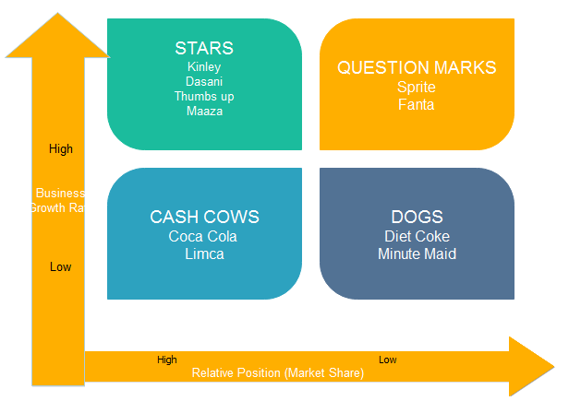

SPACE Analysis of Coca-Cola

The SPACE matrix is otherwise referred to as Strategic Position & Action Evaluation matrix. It is a management tool that is used mainly to formulate strategies that relate to an organization’s competitive position. The analysis looks at four main areas that affect an organization’s competitiveness in both its internal and external environment. In the external environment, it evaluates the attractiveness of the industry and the stability of the environment in which it exists whereas in the internal environment it looks at the organization’s competitive advantage and its financial strength. Combination of the ratings of each dimension on the matrix provides a guide for the strategic agenda of an organization thus determining whether it should take a conservative, aggressive, defensive or competitive approach to strategy formulation (Halmagyi & Yasnov, 2009).
Thus, analyzing Coca-Cola while using the SPACE matrix means that the four qualities named above will be scrutinized based on predetermined characteristics. Analyzing the internal strategic position of the organization is divided into the analysis of its competitive and financial positions. The characteristics that define the organization’s competitive position are market share, brand image, customer service, product quality, manufacturing expenses and customer loyalty. The financial position is analyzed based on the organization’s revenue increase, earnings per share, liquidity, return on equity, efficiency ratios, and cash flow. The external strategic position of Coca-Cola will be assessed considering the company’s industrial and environmental stability. The characteristics that determine industrial stability include industry profits, barriers to entry, technological know-how, resource utilization, financial access and growth potential. The assessment of environmental stability will focus on the price elasticity of demand inflation rates, technological changes, competitive pressure, the variability of demand and competing product prices. Each of the characteristic factors in the four main categories named above will be rated on a scale of 1 to 6. Competitive position and environmental stability will be rated on a scale of -1 to -6 with -1 representing the best score and -6 representing the worst. Industry strength and financial strength will be rated o a scale of +1 to +6 with +1 being the worst score and +6 being the best (Halmagyi & Yasnov, 2009.

SPACE Matrix
 | Internal Strategic Position |  | External Strategic Position
 | Competitive Advantage |  | Industry Stability
 | (-1 best -6 worst) |  | (+1 worst +6 best)
X  A  X  I  S | Brand Image | -1 | Financing Access | +5
X  A  X  I  S | Product Quality | -1 | Growth potential | +4
X  A  X  I  S | Market share | -1 | Technology Utilization | +5
X  A  X  I  S | Customer Loyalty | -1 | Resource Utilization | +5
X  A  X  I  S | Manufacturing Expenses | -1 | Industry Profits | +4
X  A  X  I  S | Customer Service | -2 | Barriers to entry | +3
X  A  X  I  S | Average | -1.2 | Average | +4.3
 | Total Axis Score 3.1
 | Financial Strength |  | Environmental Stability
 | (+1 worst +6 best) |  | (-1 best -6 worst)
Y  A  X  I  S | Liquidity | +3 | Technology Changes | -1
Y  A  X  I  S | Cash flow | +4 | Inflation Rate | -2
Y  A  X  I  S | Efficiency Ratios | +5 | Price Elasticity of Demand | -3
Y  A  X  I  S | Earnings per share | +3 | Demand variability | -2
Y  A  X  I  S | Revenue Increase | +3 | Competitive Pressure | -3
Y  A  X  I  S | Return on Equity | +5 | Competing Product Price | -3
Y  A  X  I  S | Average | +3.8 | Average | -2.8
 | Total Axis Score 1.0

From the graph above, it is evident that Coca-Cola should take an aggressive strategy approach. The latter is an indicator that the organization is in a favorable position within the industry that is characterized by competitive advantages that are coupled with considerable financial strength. The organization also seems to be operating in a stable and attractive industry.

Product- Positioning Map
Creating a product position map is also referred to as perceptual mapping. A product position map is a diagrammatic approach that is used by marketers of assets that seeks to visually represent the perceptions of both current and potential consumers. The organization’s position in terms of brand, product or product line is mapped relative to the competition within the market that they exist. Product positioning maps typically have two dimensions but in certain cases, they can be multi-dimensional when used to identify gaps in the market, potential merger targets or when seeking clarification of the perceptual problems that are associated with a company’s product (Quester et al., 2004). Creating an organization’s perceptual map allows the organization in question to understand their consumers better thus allowing them to be better placed to interpret consumer behavior as regards their products or services offered. In case the consumer perception of the company in question is negative, then the organization can conduct research on those grounds to determine what can be done to remedy the situation. A perceptual map similarly allows the organization to see how it is perceived especially by their competitors. In case an organization chooses to develop product position maps regularly, then they can be able to track consumer preferences and be better placed to deal with changes in the market. Product position mapping also facilitates the definition of market segments and clearly defines business clusters within the same thus providing the organization in question the opportunity to determine other businesses’ potential to partner or merge with. Perceptual mapping also allows an organization to track the progress of its new products in the market thus allowing the determination of its success or lack thereof considering its alignment with the business goals concerning positioning (Gelici‐Zeko et al., 2013).
Market segmentation is important because it allows the brand to identify the products that can suit the needs of different consumers. However, Coca-Cola does not necessarily target a specified market segment and it adjusts its market strategy through the development of new products. In terms of age, Coca-Cola does not target any specific age group, but it is mainly consumed by those between the ages of 12 and 30 years. Regardless, Coca-Cola has also managed to reach those that are not in the age bracket specified above through their partnerships with fast food franchises, restaurants or the value that the brand gives to its consumers. Thus, Coca-Cola mainly targets the youth and from statistics collected members of both genders consumer Coca-Cola products at an almost equal rate. Furthermore, every customer is considered a target as well as a potential consumer by Coca-Cola. Those between the ages of 18 and 25 depict the greatest target population potential and as such are prioritized by the organization. The organization named above is not occupation oriented and instead tends to be family oriented (Sinha et al., 2009).
Initially, Coca-Cola’s brand position was under a medicine patent as a cure for both fatigues and headaches. However, the latter was changed with the implementation of the tax imposition of 1898. As of 2014, the organization’s unique selling position (USP) was “Live on the Coke side of life.” Its products thrive under the perception of being refreshing and sources of quenching thirst. The latter also has a cultural value among friends and family and the joyful moments shared with others. Consumers have also associated the same with high quality and high consistency levels. Therefore, the factors that must be considered when referring to Coca Cola’s brand position include distribution, packaging, promotion, competition, and price. In terms of pricing, Coca-Cola’s prices remained constant for about 70 years regarding the prevailing and changing market conditions. Its packaging has however been altered over the years to fit market trends and maintain a superior look among other brands in the market. In terms of promotion, Coca-Cola believes in “letting the word spread,” creating awareness as well as reminders as well as keeping up with its competitors. The Coca-Cola slogan changes periodically, however, the bottom line is maintained depicting the products of offering high-quality products that bring people together (Fournier & Avery,2011).
As previously stated, Pepsi is Coca Cola’s biggest competitor. Pepsi’s current brand positioning is based on their slogan, “Live for Now.” The latter encourages their consumers to live life to the fullest and come together through music, entertainment and pop culture (Ferreira et al., 2008). In contrast, Coca-Cola appeals to an important part of people’s daily lives and creates an intimate relationship with consumers by encouraging them to summon past experiences they have had with the brand. The brand stresses that its consumers should live on the positively by creating a positive reality and also create a similar reality for others. Concerning brand differentiation, Coca-Cola stands out when compared to other brands because it has made itself out to be a symbol of both fun and joy, it has created a product line with culturally tailored products and has included an organic beverage line. Thus, the latter allows it to have a competitive advantage among its competitors in terms of being a market leader, formulation of strategic business partnerships, establishment of consumer relations that are collaborative, and multiple segmentation of the brand. Also, Coca-Cola has well-established client value management systems, an impressive and well-organized marketing strategy, expert managers, development strategies that are sustainable and a flexible sales and distribution model, all of which are factors that give it an advantage over its competitors (Cayla & Arnould, 2008).

Product Positioning Map
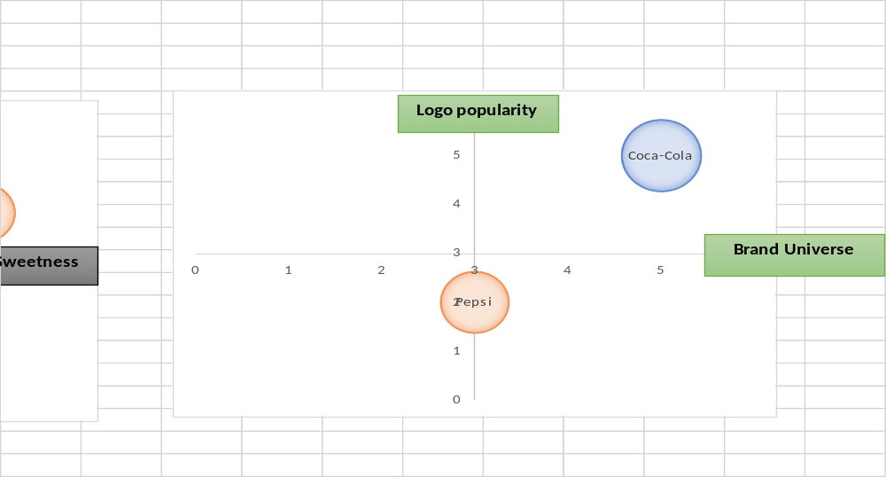
From the maps above, it is evident that consumers prefer Pepsi’s taste to Coca-Cola’s. Both drinks have similar amounts of caffeine, but Coca-Cola’s logo popularity is significantly higher when compared to Pepsi’s. Coca-Cola has also established an extensive brand universe compared to Pepsi, all of which are contributing factors to the market share each of the two brands possesses with Coca-Cola being the biggest shareholder garnering 42% with Pepsi holding 30%.

Strategies and Objectives for most Favorable Market Position
If Coca-Cola is to continue growing and manage to at maintain and further increase its market position, it must consider adopting new strategies over time to allow the organization to be better placed to succeed regardless of the prevailing market conditions. However, strategic changes should focus on increasing the strengths of the organization and decreasing its weaknesses as well as maximally exploiting the opportunities available to the same and mitigating the effects of the threats thereof. First, considering the stiff competition that Coca-Cola faces from Pepsi, the organization must strategize to find means through which it can eliminate the competition once and for all. To begin with, Coca-Cola can find means to further diversify their product portfolio such that they reach a wider range of consumers. Heightened consumer numbers translate into higher revenue, increased brand awareness and often an increased market share which will mean that the stiff competition from Pepsi may be reduced significantly.
Similarly, with the increasing rate of consumer preference changes, Coca-Cola should consider exploring new product lines that consumers are likely to be more interested in. In an era characterized by increased health awareness resulting from the escalation of the prevalence of lifestyle diseases, the organization should consider investing more in the production of healthier drink choices. The healthier the drinks they produce, the higher the number of consumers they are likely to attract thus allowing them to secure a more favorable market position. Resource management is also a key factor that must be considered if the organization is to maintain a favorable position in the market. The latter means that the management team should ensure that resources are allocated in a manner that allows their effective and efficient utilization, avoiding over-allocation of the same across projects. With that respect, the resource allocators must also understand that there is a need to focus resources on one project at a time instead of abandoning ongoing projects for new ones if the organization is to succeed in the project implementation process because fragmentation negatively impacts progress and results (Sirmon et al., 2008).
With the constant changes in the business environment, for Coca-Cola to maintain a competitive advantage over its competitors, it must consider reinventing its supply chain to fit the current trends in the market. The more the supply of Coca-Cola products meets the needs of consumers, the higher the chances of organizational success as the latter is likely to translate into increased brand loyalty. Moreover, Coca-Cola should consider allocating more advertising resources to the less popular brands to increase their popularity among consumers. The latter is likely to lead to an increased consumer base as people adapt to the consumption of the less popular products. On the other hand, Coca-Cola must look to find means to decrease or eliminate indirect competition. The latter may be done by making the organization a beverage company rather than a soft drink company. In so doing, the indirect competitors will now become direct competitors thus allowing Coca-Cola to have higher chances of success in maintaining its market position or further strengthening the same.

Selected Strategy: Product Portfolio Diversification.
Product portfolio diversification is a term that is used to refer to the processes that are involved in expanding business opportunities by adding the market potential of a brand that already exists. An organization/ business may achieve diversification through entry into new markets or changing their pricing strategies. The new products are likely to be changed or improved or the marketing activities associated with the product/brand in question altered. In the case that an organization is looking to diversify their product portfolio, they must set the objectives of the latterly named move and their approach towards the same may be defined as either defensive or offensive. A defensive approach can be adapted when a business is looking to beat stiff competition, increase lowered demand for their products or add more products to a brand that was built based on a single product. An offensive portfolio diversification approach is however adapted in case there is a strong market opportunity and the existing company products cannot be used to exploit the same (Jacobs & Swink, 2011).
As Coca-Cola considers taking on a product portfolio diversification approach to attaining a favorable market position, the organization should use both offensive and defensive tactics with that regard to fully exploit organizational potential and maintain their position as market leaders. For Coca-Cola to gain a competitive advantage and maintain a market position that is favorable it must beat the stiff competition that Pepsi and other beverage organizations offer. Similarly, the defensive approach to product diversification at Coca-Cola will allow the organization to heighten the demand of its products whose demand has seemingly decreased, like is the case with its carbonated sugary drinks in developed countries. The later will also allow Coca-Cola to increase its products to include more than the initially branded ones thus raising the organizational changes of increasing its customer base considering the wider range of products to choose from. On the other hand, an offensive approach to diversification would allow Coca-Cola to exploit the new market for healthier drinks since the consumer preferences have seemingly been moving in that direction in the recent past.
The stiff competition between Coca-Cola and Pepsi has existed since the late nineties which have been branded as the cola wars. The latter is characterized by marketing campaigns as well as television advertisements created by both organizations targeting mutual areas of interest. During the short periods of competition between the two companies, the organizations contrast based on the strategies that they employ to avoid competition, their focus on different consumers, sponsorship of differing sports and differentiation of logos among others (Crosetto & Gaudeul, 2017). Hence, for Coca-Cola to gain a more suitable market position with that regard, they should further diversify their product portfolio to include products that are not offered by Pepsi such that they can take possession of a market niche within which the competition is not as stiff as the rest or where the same is minimal. Moreover, when Coca-Cola company was established, the drink that it promoted mainly was Coke, also referred to as Coca-Cola. Over the years, as the company grew and the trends in the market changed, there was a need to diversify the products offered and the latter saw to the introduction of others like Fanta and Sprite. The same was the cause for the introduction of other products including bottled water, minute maid and diet coke among others. However, the changes that already exist with regard to product portfolio diversification cannot be considered satisfying since the market trends are still changing which means that the consumer preferences resultantly keep diversifying. In the current market, consumers beverage and food trends are dominantly inclined to healthier choices such that even established organizations like Coca-Cola are either looking to reformulate their old brands or introduce new products altogether to satisfy consumer needs and maintain a market position that is favorable. According to surveys, consumer preferences for drinks that are healthier indicate that about 90% of consumers are more than willing to pay more to enjoy the benefits of high-quality goods (Hoke et al., 2017). The latter is likely to propel the offensive approach to product diversification that Coca-Cola is likely to take. The current beverage market provides an incredible opportunity for the organization to grow in terms of the products offered to consumers as well as revenue accrued. Since Coca-Cola has previously focused on the production of sugary carbonated drinks, part of its diversification strategy should include introducing drinks that are healthier and advertising them frantically to increase consumer awareness of the new products. This will allow the organization to tap into a new market niche which will potentially translate into increased revenue and a better market position.

Implementation and Assessment Plan
The first step towards implementing the diversification plan will be conducting a market research. Market research is also referred to as industrial research which accounts for application of organized efforts to collect information concerning consumers in Coca Cola’s target market. The latter allows the evaluation of both social and opinion aspects provided by the consumer making it essential to strategic business approach. Market research allows the organization to maintain a competitive advantage over their competitors allowing them to remain as market leader in the niche within which they operate. It offers the researcher an opportunity for identification and analysis of needs in the market regardless of whether the approach towards the same is quantitative or qualitative (McQuarrie, 2015). Coca Cola’s market research would, therefore, cover aspects of market trends, information, segmentation as well as SWOT analysis, among others, most of which have been highlighted in the three phases of this research.
The next step to be taken towards implementation is the analysis of product adaption. The term product adaptation refers to the modification of products that that already exist such that they are more suited to cater to the needs of different market niches and consumers. Considering that Coca-Cola operates across international borders, analysis of product adaption is necessary since it will ensure that the product (s) the organization offers its consumers meet both the cultural and regulatory requirements thereof. Product adaptation would also be essential as Coca-Cola looks to introduce new products which are not necessarily new items. Analysis of product adaptation will, therefore, entail the evaluation of consumers, research, and competition as well as finally set priorities to determine the exact nature through which product adaptation should be implemented (Sridhar & Mishra, 2011). Product adaptation analysis will allow Coca-Cola to determine which diversification approach it should implement and in which regions depending on the market niche needs in thereof.
The last step of product diversification is a legal review. Legal review entails sending a document or documents to a legal professional for them to review and send feedback (Clayton, 2015). Legal reviews are important to the diversification process as they ensure that the efforts the organization makes towards the same are in line with the set laws to avoid resource wastage associated with dealing with legal issues. The latter also allows the organization to avoid the bad publicity that may result from legal implications which may cause reduced consumer confidence in the products offered by the organization.
The specific results that must be achieved through the latterly described implementation process include increased market share. Through product diversification, Coca-Cola should be able to control about 50% of the market or more before the end of the next financial year. Similarly, the organization should be able to increase its financial stability because of product diversification meaning that the brand value should increase to about 74 billion from 73.1 billion US dollars and the operating revenue increase from 41.86 to 42.5 billion US dollars within the next year. In terms of product, the strategy explained above should allow Coca-Cola to introduce at least five new products in the next year, mainly focusing on introducing healthier choices and tapping into new market niches. Furthermore, the organization should be well placed to offer better services to its consumers who will be able to access healthier drink choices from a trusted brand (Thomas, 2009) The effectiveness of the implementation process will be evaluated after every three months with regards to the set market, financial, product and service goals. Each assessment will include documentation of evidence in photos, figures and graphs depending on the most appropriate way of presentation of data collected and the goals being assessed. At the end of the financial year, all the evidence that was documented within the same will be compiled to establish the trend concerning goal attainment. Similarly, the gap between the reported organizational performance and the set goals, if any, will be analyzed to justify the same and determine what Coca-Cola can do to eliminate it and increase the chances of attaining the goals set for the next financial year. The evidence will be collected mainly through analysis of accounting records and monitoring social media as well as customer care channels to determine consumer response to the brand and its specific products. A special strategy assessment team will be put together comprising of members from different management levels to conduct the periodic assessments that will determine the effectiveness of implementation of the product diversification strategy.

Financial Projection
Financial projections are comprised of estimated values of future organizational performance. They are important to the success of a business because they establish clear guidelines through which organizational success may be measured. In the case that financial projections are made regularly, organizations are better placed to deal with change that occurs in both its external and internal environment. Financial projections also allow the evaluation of an organization’s strengths and weaknesses as well as the determination of available opportunities thus allowing the organization to be prepared to exploit the same. The same applies to the recognition of problems and threats that the organization may face leading to timely reactions that mitigate the negative effects that may result from the same. Generally, financial projections allow the organization to react to the changing marketing conditions in a manner that allows it to maximally benefit from the same. The main objectives of creating financial projections include; it facilitates the translation of organizational goals into specific goals, it acts as a feedback and control tool in the organization and allows problem anticipation to better prepare for the same (Chilombo et al., 2008).
The type of financial projection created is dependent on an organization’s objectives as well as its situation. The first type of projection that can be made is an annual forecast that may be updated monthly making it the main monitoring and evaluation tool within the organization. The latterly named type of projection also forms the basis for the creation of other types of forecasts. An organization may also choose to work with a long-term projection which forecasts its financial position over the next 3-5 years. Unlike the short-term forecast that is characterized by tactical and expectation plans, the long-term projection accounts for the strategic organizational goals in place. Similarly, financial projections may be characterized by budgets that translate the goals of an organization into temporary targets and detailed actions that may include details of organizational plans regarding staffing and expenditure on line items. Lastly, financial projections are also characterized by cash flows which further breakdown annul forecasts into greater detail targeting the monitoring of the flow of cash within an organization rather than the profits accrued by the same. A well-established financial plan should have cash needs that are properly defined through the creation of an accompanying cash flow statement. Thus, the financial projection made for Coca-Cola is a long-term forecast that accounts for three years after the end of the 2017 financial year (Chilombo et al., 2008).
The key elements of a financial projection include the income statement, cash flow projection, and the balance sheet. The income statement is comprised of all aspects of a business including its expenses, profits, and revenues within the specified period. The main sections of the income statement are revenue, expenses, total income, income taxes and net income. Next is the cash flow projection. It records the flow of cash in a business and can be used to convince potential investors or creditors that the latter has a good credit risk and can manage to pay back a loan if in case it is granted. The main parts of the cash flow projection include cash revenues, disbursements and the reconciliation of cash revenues to disbursements. The balance sheet provides an overview of how much a business is worth within a specific period. It summarizes the financial data associated with a business into three categories, that is, assets, liabilities, and equity (Elliott & Elliott, 2007).
The Coca-Cola financial projection below indicates that the net operating revenue in the financial year that ended on the 31st of March 2017 was $41863 million and the figure is expected to rise steadily and at the end of the three-year period that the projection covers be $73219 million. The gross profit that was recorded in the 2017 financial year was $25398 million and the figure is expected to rise to $53205 million after three years. The organization’s net income, income before taxes and consolidated net income are expected to rise significantly with margins of over $12 million over the projected period. In the statement of cash flows, the net cash that is accrued from operating activities is expected to increase from $5668 to $ 46634. Similarly, the net cash that is used in investing is also expected to increase from $1794 million to $21153 million at the end of the three-year projection period. The balance at the beginning of the period is expected to increase from $4093 million to $5182 million while the balance at the end of the period is forecasted to decrease progressively from $7797 million to $5442 million. In the balance sheet, the organizational total assets are expected to double within the three years while total equity is expected to triple. See the spreadsheet below for details.

Coca-Cola 3-Year Financial Projection.
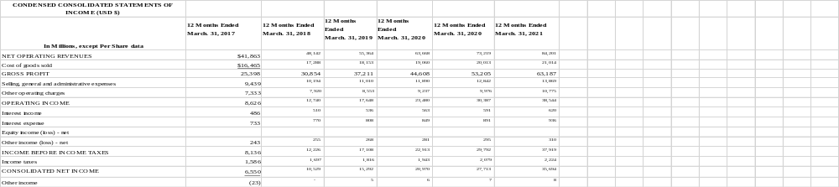

References

Armus, S. (2005). Coca-Cola Company. France and the Americas: culture, politics, and history: a multidisciplinary encyclopedia, 1, 273.
Arnett, G. (2015). How Coca-Cola is fighting against a US public losing the taste for it. The Guardian.
Ayub, A., Adeel, R., Muhammad, S. A., & Hanan, I. (2013). A conceptual framework for evaluating SWOT analysis as the mediator in strategic marketing planning through marketing intelligence. European Journal of Business and Social Sciences, 2(1), 91-98.
Baah, S., & Bohaker, L. (2015). The Coca-Cola Company. Culture, 16, 17.
Berry, S. (2010). How Coca-Cola’s distribution system works.
Bethuy, T. W., Black, W. J., Cahill, B. T., Nelson, A. D., & Mehn, P. D. (2007). U.S. Patent No. 7,156,259. Washington, DC: U.S. Patent and Trademark Office.
Blanding, M. (2011). The Coke machine: The dirty truth behind the world's favorite soft drink. Penguin.
Bose, R. (2008). Competitive intelligence process and tools for intelligence analysis. Industrial Management & Data Systems, 510-528.
Butler, D., & Tischler, L. (2015). Design to Grow: How Coca-Cola Learned to Combine Scale and Agility (and how You Can Too). Simon and Schuster.
Cayla, J., & Arnould, E. J. (2008). A cultural approach to branding in the global marketplace. Journal of International Marketing, 86-112.
Chilombo, N., Doetinchem, O., & Kansembe, H. (2008). Financial projections for social health insurance in Zambia. Genève, Organisation mondiale de la santé (non publié).
Clayton, C. W. (2015). The Politics of Justice: Attorney General and the Making of Government Legal Policy. Routledge.
Coffey, T. S. (2008). Diet Coke and Mentos: What is really behind this physical reaction? American Journal of Physics, 551-557.
Company, O., Main, O., Journey, A., Mission, V., Inclusion, D., & Rights, H. et al. (2017). Coca-Cola Journey Homepage. The Coca-Cola Company. Retrieved 28 October 2017, from http://www.coca-colacompany.com/
Company, O., Main, O., Journey, A., Mission, V., Inclusion, D., & Rights, H. et al. (2017). Coca-Cola Leaders. The Coca-Cola Company. Retrieved 28 October 2017, from http://www.coca-colacompany.com/our-company/leadership
Crosetto, P., & Gaudeul, A. (2017). Choosing not to compete: Can firms maintain high prices by confusing consumers? Journal of Economics & Management Strategy, 897-922.
David, F. R. (2011). Strategic management: Concepts and cases. Pearson/Prentice Hall.
Dhalla, R. (2007). The construction of organizational identity: Key contributing external and intra-organizational factors. Corporate Reputation Review, 245-260.
Elliott, B., & Elliott, J. (2007). Financial accounting and reporting. Pearson Education.
Esterl, M. (2016). "Coca-Cola Buys Minority Stake in Suja Life". Wall Street Journal.
Estrel, M. (2015). Coca-Cola Boosted by Sales of Tea, Bottled Water. The Wall Street Journal.
Ferreira, M., Hall, T. K., & Bennett, G. (2008). Exploring brand positioning in a sponsorship context: A correspondence analysis of the Dew Action Sports Tour. Journal of sports management, 734-761.
Fosfuri, A., & Giarratana, M. S. (2009). Masters of war: Rivals' product innovation and new advertising in mature product markets. Management Science, 181-191.
Fournier, S., & Avery, J. (2011). The uninvited brand. Business Horizons, 193-207.
Gelici‐Zeko, M. M., Lutters, D., Klooster, R. T., & Weijzen, P. L. G. (2013). Studying the influence of packaging design on consumer perceptions (of dairy products) using categorizing and perceptual mapping. Packaging Technology and Science, 215-228.
Halmagyi, N., & Yasnov, V. (2009). The spectral curve of the lens space matrix model. Journal of High Energy Physics, 2009(11), 104.
Helms, M. M., & Nixon, J. (2010). Exploring SWOT analysis–where are we now? A review of academic research from the last decade. Journal of strategy and management, 3(3), 215-251.
Hoke, O., Campbell, B., Brand, M., & Hau, T. (2017). Impact of Information on Northeastern US Consumer Willingness to Pay for Aronia Berries. HortScience, 395-400.
Jacobs, M. A., & Swink, M. (2011). Product portfolio architectural complexity and operational performance: Incorporating the roles of learning and fixed assets. Journal of Operations Management, 677-691.
Krützkamp, K. (2013). Celebrity-Marketing: Market penetration by image transfer from stars using the example of the brand Coca-Cola light of the beverage producer Coca-Cola.
Levin, R. (2013). Driving the top line with technology: An interview with the CIO of Coca-Cola. McKinsey Insights and Publications.
McKelvey, S. M. (2006). Coca-Cola vs. PepsiCo-A" Super" Battleground for the Cola Wars? Sports Marketing Quarterly, 114.
McLellan, H. (2006). Corporate storytelling perspectives. The Journal for Quality and Participation, 29(1), 17.
McQuarrie, E. F. (2015). The market research toolbox: a concise guide for beginners. Sage Publications.
Nair, A., & Selover, D. D. (2012). A study of competitive dynamics. Journal of Business Research, 355-361.
Palia, A. P., De Ryck, J., & Mak, W. K. (2014). Interactive Online Strategic Market Planning with the Web-based Boston Consulting Group (BCG) Matrix Graphics Package. Developments in Business Simulation and Experiential Learning, 29.
Pendergrast, M. (2013). For god, country, and coca-cola. Basic Books.
Pike, A. (2009). Brand and branding geographies. Geography Compass, 3(1), 190-213.
Quester, P. G., McGuiggan, R. L., Perreault, W. D., & McCarthy, E. J. (2004). Marketing: creating and delivering value.
Raisch, S., Birkinshaw, J., Probst, G., & Tushman, M. L. (2009). Organizational ambidexterity: Balancing exploitation and exploration for sustained performance. Organization Science, 685-695.
Schneider, S. (2016). How to design a measurable shared value strategy: the case of Coca-Cola Brazil (Doctoral dissertation).
Sinha, J. I., & Rosenthal, E. C. (2009). The costs and perils of over-targeting in today's markets. The Marketing Review, 243-250.
Sirmon, D. G., Gove, S., & Hitt, M. A. (2008). Resource management in dyadic competitive rivalry: The effects of resource bundling and deployment. Academy of Management Journal, 919-935.
Sohel, S. M., Rahman, A. M. A., & Uddin, M. A. (2014). Competitive profile matrix (CPM) as a competitors’ analysis tool: A theoretical perspective. International Journal of Human Potential Development, 3(1), 40-47.
Solomon, M. R. (2009). Marketing: Real people, real decisions. Pearson Education.
Sridhar, G., & Mishra, D. (2011). Executives social representation of rurality and product adaptation: a case of rural markets in India. Asia Pacific Journal of Marketing and Logistics, 285-303.
Steinhardt, G. (2010). Extending product life cycle stages. In the Product Manager's Toolkit (pp. 69-76). Springer Berlin Heidelberg.
Thomas, M. (2009). Belching out the devil: Global Adventures with Coca-Cola. Nation Books.
Wedel, M., & Kamakura, W. A. (2012). Market Segmentation: Conceptual and methodological foundations (Vol. 8). Springer Science & Business Media.
Zishan, F. (2017). PROJECT REPORT ON COCA-COLA COMPANY SUBMITTED BY · MUTHU KUMARAN. Academia.edu. Retrieved 29 October 2017, from http://www.academia.edu/7569416/PROJECT_REPORT_ON_COCA-COLA_COMPANY_SUBMITTED_BY_MUTHU_KUMARAN

